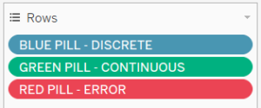

1. **Product Name – Discrete (Blue Pill) and Dimension**

https://www.thedataschool.co.uk/content/images/wordpress/2018/02/Product-Name.png

Product name is a dimension – you cannot add up or average names

It is also a discrete data set – you are restricted to each individual name, you cannot have a continuous scale of names

1. **Profit – Continuous (Green Pill) and Measure**

https://www.thedataschool.co.uk/content/images/wordpress/2018/02/Green-Product-Name.png

Profit is a measure – you can add up or average the profit. You can measure how much profit there is.

It is also a continuous data set – it can take on any value, you can have a profit of 0 or 1 billion or -3.5 for instance.

**c) Dates – Discrete OR Continuous Dimensions**

Date fields are interesting examples are they are dimensions that can be either discrete or continuous. As we can see below, you can have:

• **discrete** dates, where the value inside (Abc) corresponds to only that year.

https://www.thedataschool.co.uk/content/images/wordpress/2018/02/Date-blue.png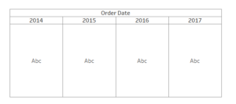

• **continuous** dates, where the value could correspond to any date within that scale

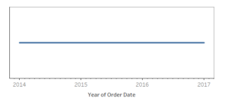https://www.thedataschool.co.uk/content/images/wordpress/2018/02/Date-green.png